First you go to the website which is
Product iQ | UL Solutions
Then you login (you can make an account if you don’t have an account)
When you login then you go to the iQ Family of Databases (left side of the window). When you clock on window then you get a window like below . click on the window which is shown below.
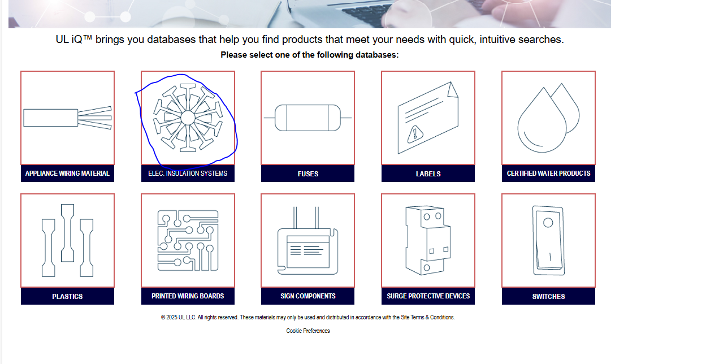
Then a new window will open, here click on the component search as shown in the picture below.
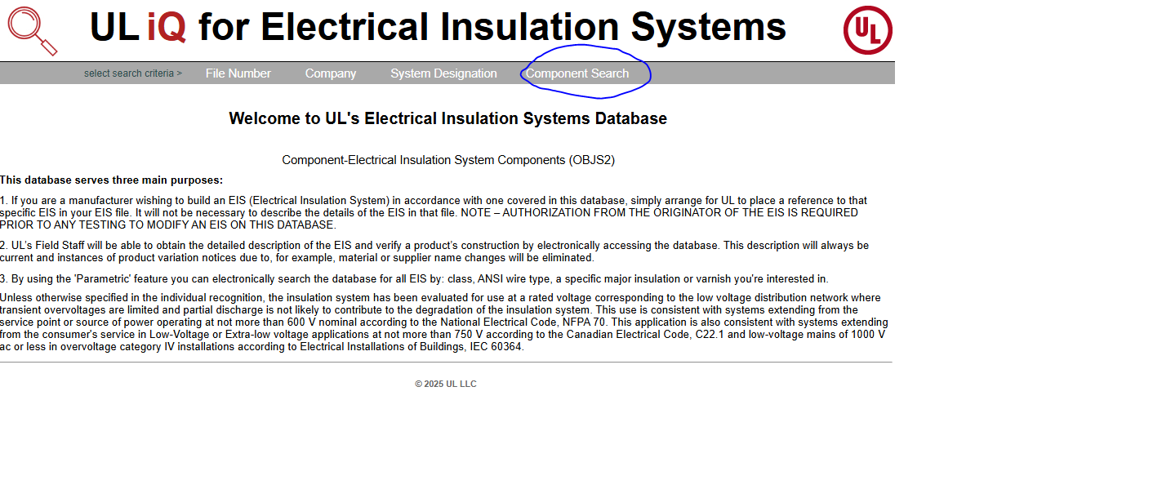
Now a new window will open, here click on the Manufactures of certified varnish , click on the arrow to show all different varnish companies. Here select John C Dolph Co as we are using this company varnish at the moment. The picture below shows it, it also shows that after selecting the Manufacture of Certified Varnishes, a new window will open which will say “please select a varnish”. Here select CC-1105, CC-1105HT…….. Then click on Search.
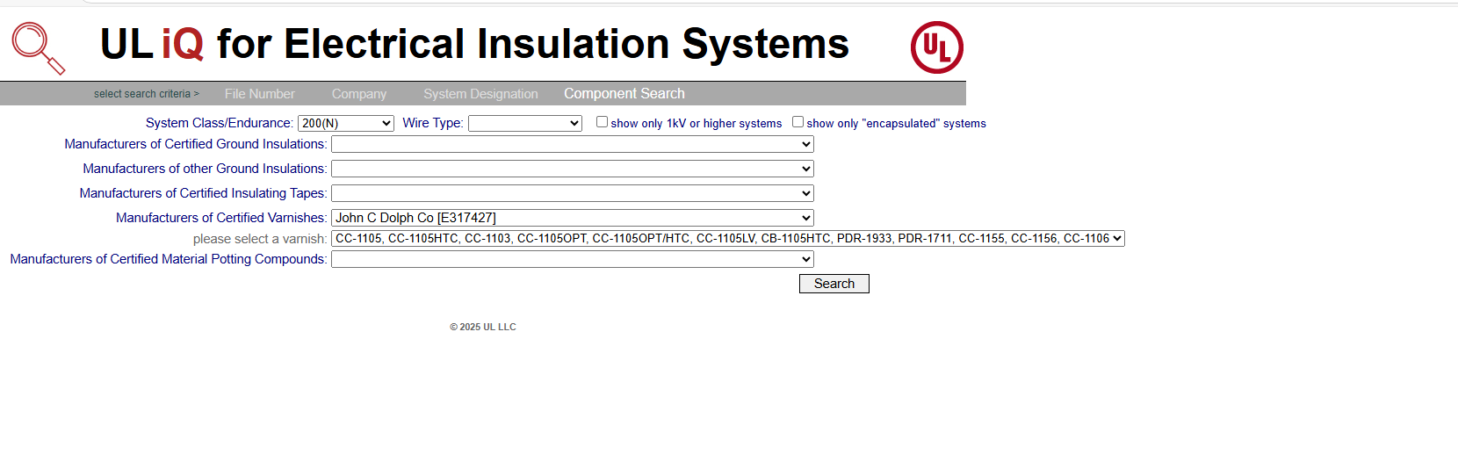
Here you will keep the endurance class to 200(H) or whatever the maximum temperature you want to or expect within the machine ( better to be more compared to what we are getting). Then click on anyone with the 200(N) Class/Endurance as shown in the picture below.
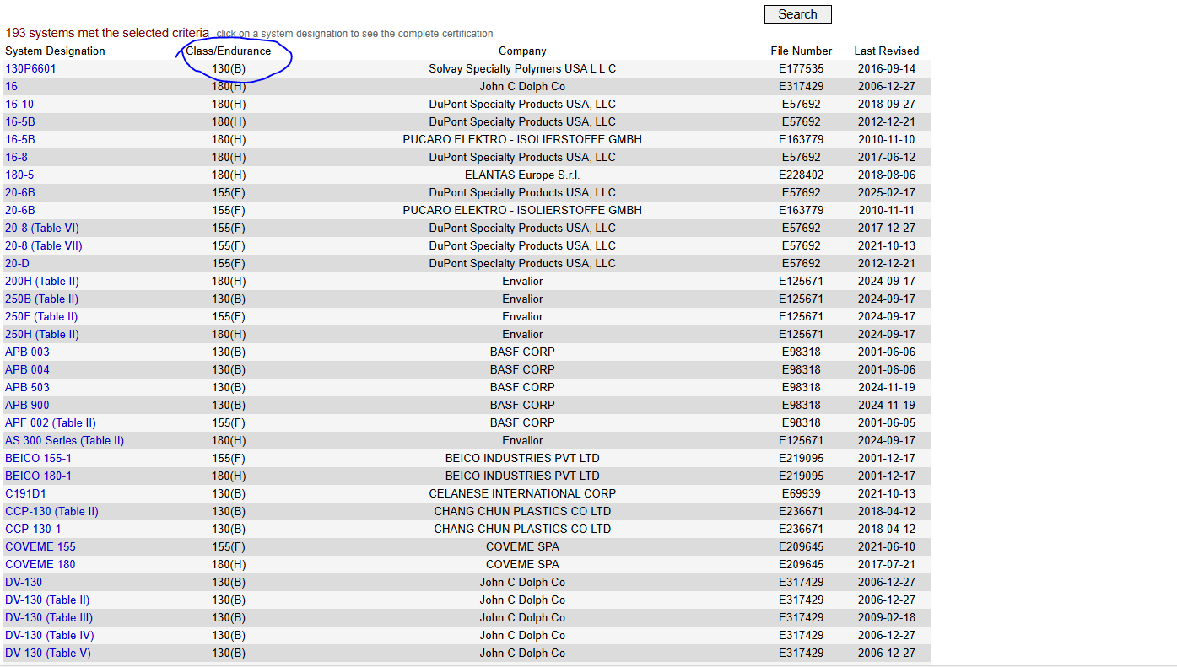
When you click on the one with 200 (N) class/Endurance, it will take you to a page where all other stuff was used along with the varnish which we used in the first case. It will show you the kind of slot wedges and slot liners and all other stuff used with that varnish during that experiment.
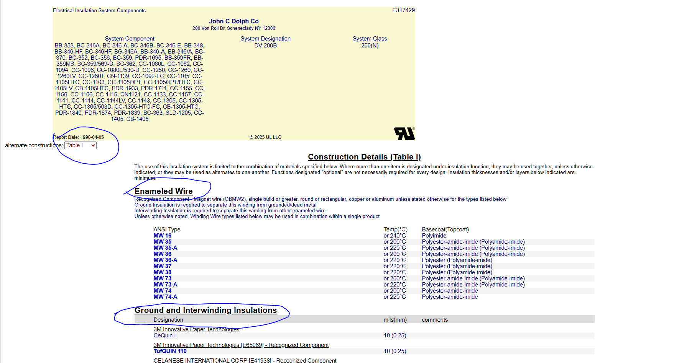

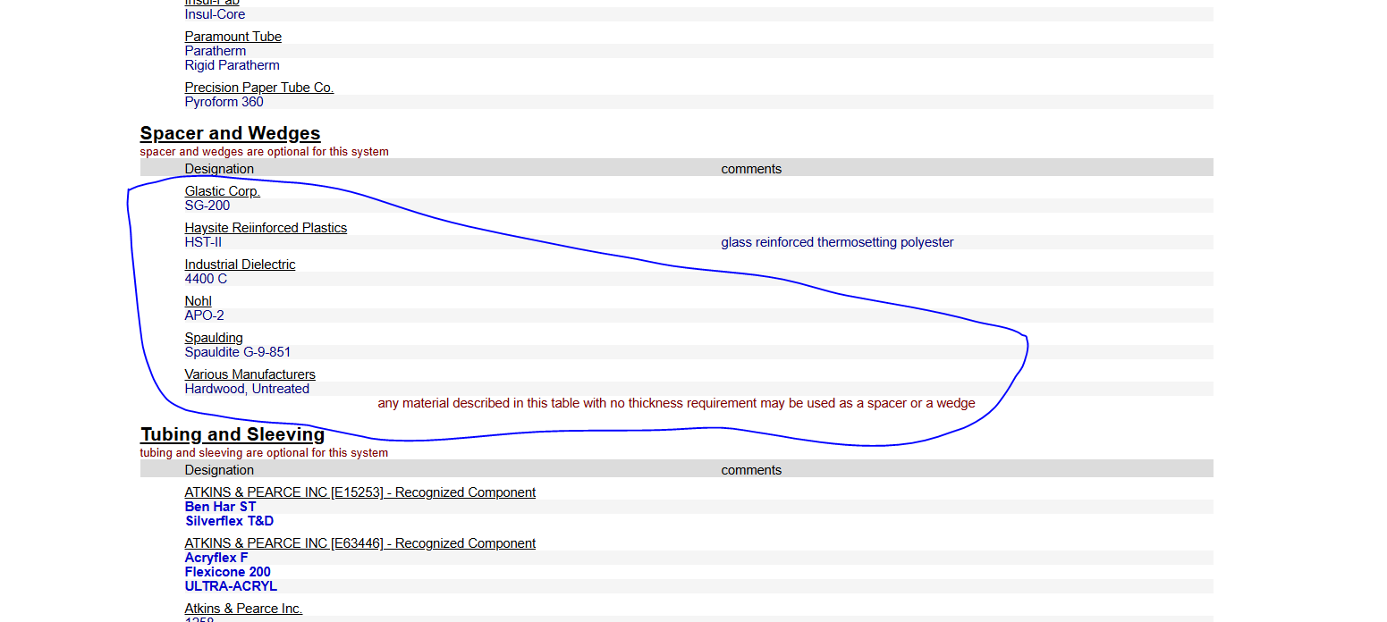

Now in the spacer and wedges, you can see that different materials are used, you click search for these materials in google to find out these properties. Also keep in mind that there are other 200 (N) categories and you can scroll through all those categories for which the varnish is used. You can find those categories and its data by clicking on the Table which will be on the left as shown in the picture above.
It will take some time to get the required material which you want as the name of these materials may be different than what is normally used by the outside world.

